**Table S1: Characterization and processing conditions of the used virgin and recycled PLA.**

|  |  |  |
| --- | --- | --- |
|  | Virgin PLA | Recycled PLA |
| Composition | PLA - 99 % CAS: 9051-89-2 | PLA – 10 % CAS: 9051-89-2 + Recycled PLA 90 % |
| Density | 1.24 g/cm3 | 1.1-1.3 g/cm3 |
| Diameter | 1.75 ± 0.03 mm | 1.75 mm |
| Printing temperature | 220 ± 20 ºC | 205 ± 15 ºC |
| Melting temperature | 180 ºC | 160 ± 10 ºC |

**Table S2: Experimental plan.**

|  |  |  |  |  |  |  |  |  |  |
| --- | --- | --- | --- | --- | --- | --- | --- | --- | --- |
| Test | Phase I | | | | | Phase II | | Phase III | |
| M | LH | IP | ID | PS | M | ID | M | O |
| 1 | V | 0.15 | Tri-hex | 60 | 40 | V | 70 | V | H |
| 2 | V | 0.3 | Tri-hex | 60 | 80 | V | 100 | V | H |
| 3 | V | 0.15 | Grid | 60 | 80 | V | 40 | V | H |
| 4 | V | 0.3 | Grid | 100 | 80 | V | 85 | V | H |
| 5 | V | 0.3 | Tri-hex | 100 | 40 | V | 55 | V | H |
| 6 | V | 0.15 | Tri-hex | 100 | 80 | R | 85 | R | H |
| 7 | V | 0.15 | Grid | 100 | 40 | R | 70 | R | H |
| 8 | V | 0.3 | Grid | 60 | 40 | R | 55 | R | H |
| 9 | R | 0.15 | Tri-hex | 60 | 40 | R | 100 | R | H |
| 10 | R | 0.3 | Tri-hex | 60 | 80 | R | 40 | R | H |
| 11 | R | 0.3 | Grid | 60 | 40 |  |  | V | V |
| 12 | R | 0.15 | Tri-hex | 100 | 80 |  |  | V | V |
| 13 | R | 0.3 | Tri-hex | 100 | 40 |  |  | V | V |
| 14 | R | 0.15 | grid | 60 | 80 |  |  | V | V |
| 15 | R | 0.15 | grid | 100 | 40 |  |  | V | V |
| 16 | R | 0.3 | grid | 100 | 80 |  |  | R | V |
| 17 |  |  |  |  |  |  |  | R | V |
| 18 |  |  |  |  |  |  |  | R | V |
| 19 |  |  |  |  |  |  |  | R | V |
| 20 |  |  |  |  |  |  |  | R | V |
| 21 |  |  |  |  |  |  |  | V | E |
| 22 |  |  |  |  |  |  |  | V | E |
| 23 |  |  |  |  |  |  |  | V | E |
| 24 |  |  |  |  |  |  |  | V | E |
| 25 |  |  |  |  |  |  |  | V | E |
| 26 |  |  |  |  |  |  |  | R | E |
| 27 |  |  |  |  |  |  |  | R | E |
| 28 |  |  |  |  |  |  |  | R | E |
| 29 |  |  |  |  |  |  |  | R | E |
| 30 |  |  |  |  |  |  |  | R | E |

Notes: Material (M), Layer height (LH), Infill pattern (IP), Infill density (ID), Printing speed (PS), O (Orientation), Virgin (V) and Recycled (R) for material, edgewise (E), horizontal (H) and vertical (V) for orientation.

**Table S3: Results obtained for the maximum load output.**

|  |  |  |  |
| --- | --- | --- | --- |
| Test | Maximum load (kN) | | |
| Phase I | Phase II | Phase III |
| 1 | 2.21 | 2.15 | 1.96 |
| 2 | 2.16 | 3.29 | 1.98 |
| 3 | 2.24 | 1.87 | 2.01 |
| 4 | 3.59 | 2.30 | 2.01 |
| 5 | 3.60 | 1.98 | 2.06 |
| 6 | 3.80 | 2.24 | 1.80 |
| 7 | 3.79 | 2.08 | 1.86 |
| 8 | 2.16 | 1.93 | 1.84 |
| 9 | 2.20 | 3.03 | 1.88 |
| 10 | 2.16 | 1.80 | 1.84 |
| 11 | 2.15 |  | 1.55 |
| 12 | 3.38 |  | 1.45 |
| 13 | 3.37 |  | 1.53 |
| 14 | 2.05 |  | 1.49 |
| 15 | 3.53 |  | 1.51 |
| 16 | 3.49 |  | 1.37 |
| 17 | 2.20 |  | 1.31 |
| 18 | 2.16 |  | 1.23 |
| 19 |  |  | 1.31 |
| 20 |  |  | 1.33 |
| 21 |  |  | 1.45 |
| 22 |  |  | 1.77 |
| 23 |  |  | 1.73 |
| 24 |  |  | 1.70 |
| 25 |  |  | 1.75 |
| 26 |  |  | 1.66 |
| 27 |  |  | 1.63 |
| 28 |  |  | 1.58 |
| 29 |  |  | 1.66 |
| 30 |  |  | 1.60 |

**Table S4: Results of** **ANOVA including the type of material.**

|  |  |  |  |  |  |
| --- | --- | --- | --- | --- | --- |
| Factor | Degrees of freedom | Sum of squares | Mean squares | F-Valor | Pr(>F) |
| Layer height | 1 | 14783 | 14783 | 1.4678 | 0.25354 |
| Infill pattern | 1 | 594 | 594 | 0.0589 | 0.81309 |
| Infill density | 1 | 7909241 | 7909241 | 785.3262 | 7.773e-11 |
| Printing speed | 1 | 1156 | 1156 | 0.1148 | 0.74176 |
| Material | 1 | 100747 | 100747 | 10.0034 | 0.01011 |
| Residuals | 10 | 100743 | 10071 | - | - |
| Total | 15 | 8127264 |  |  |  |

**Table S5: Average of the load obtain for each orientation of print.**

|  |  |  |  |
| --- | --- | --- | --- |
| Orientation | Mean maximum load for virgin PLA (kN) | Mean maximum load for recycled PLA (kN) | Reduction between material (%) |
| Horizontal (H) | 2.00 | 1.85 | 7.91 |
| Vertical (V) | 1.51 | 1.31 | 12.97 |
| Edgewise (E) | 1.68 | 1.62 | 3.37 |

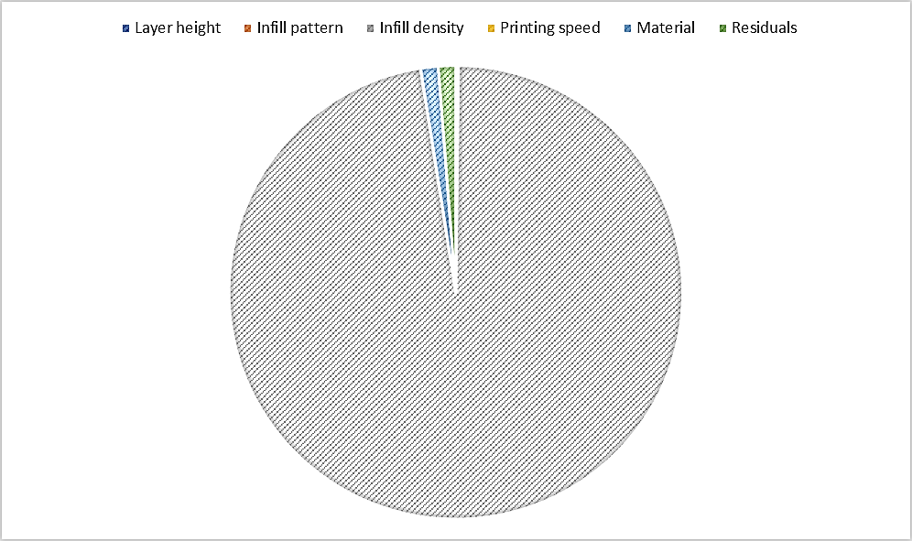

**Figure S1: Contribution to the total variability of all sources of variation.**

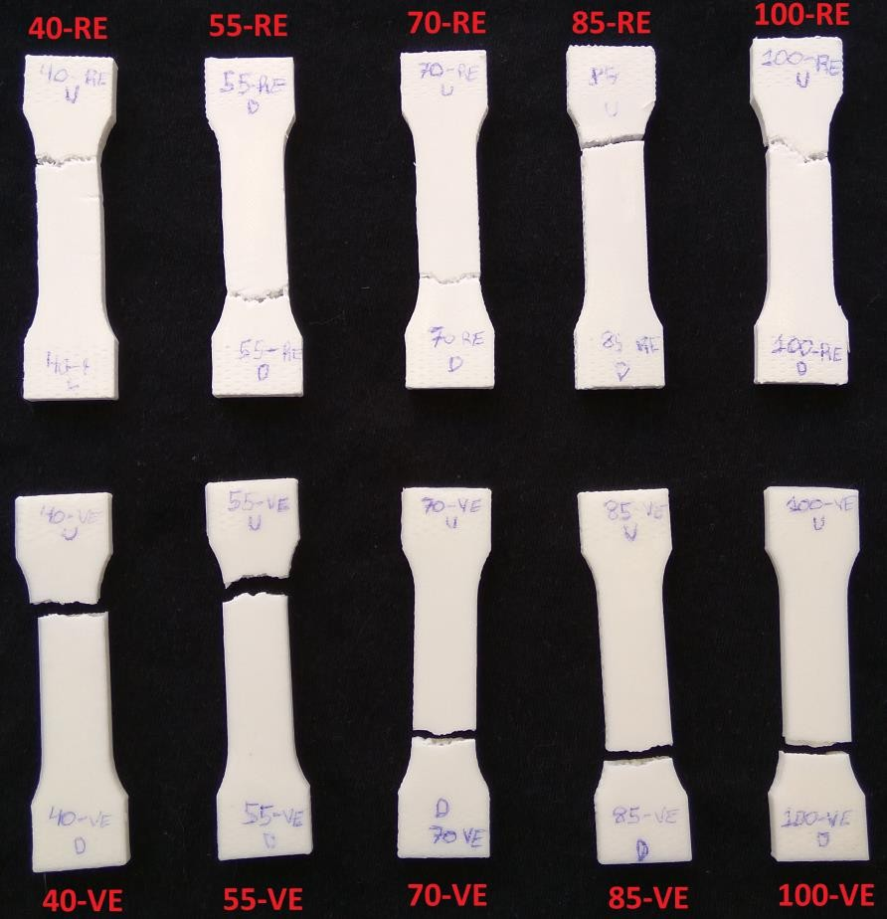

**Figure S2: Specimens after tensile strength testing (phase II).**

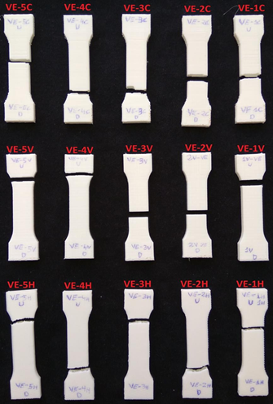

**Figure S3: Samples of virgin PLA tested to traction in phase III.**

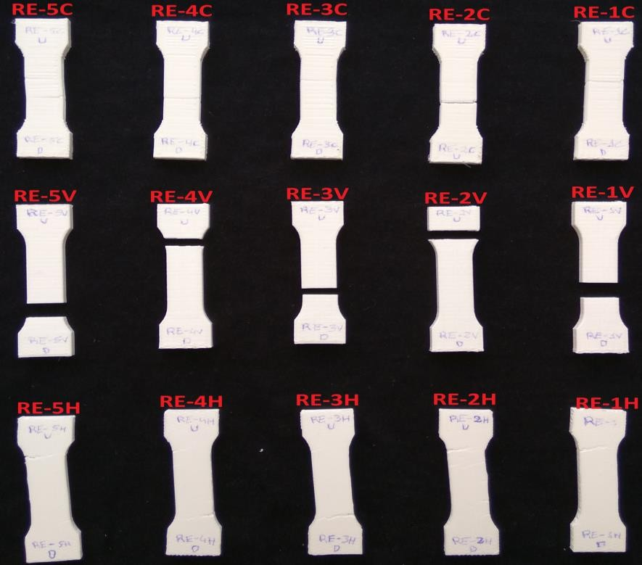

**Figure S4: Samples of recycled PLA tested to traction in phase I.**